**GROUP-7 (PROJECT-2)**

**MEMBERS WITH STUDENT NUMBERS :-**

1. SONI DEV ALPESHBHAI – 130759210
2. SINGH MANNAV – 135675213
3. TONGA YONKEU SERGE – 056728132

**DEFINING THE PROBLEM**

You are the administrator for a Linux based system. Several of your users have been working on documents over the past few weeks but suddenly they cannot modify the documents any more. They can see them in the directory and they can read their contents but they cannot make changes to them.

Who is affected by the problem ?

Users who are working for our group are affected by the problem.

What is the problem ?

Several users cannot be able to modify the documents that they have been working from the past few weeks.

Where is the problem ?

The problem is in the permissions which have been allocated to that document which was prepared by the users.

When is the problem ?

The problem is when the users try to edit or modify the information in the document.

**FISHBONE DIAGRAM (ISHIKAWA DIAGRAM)**

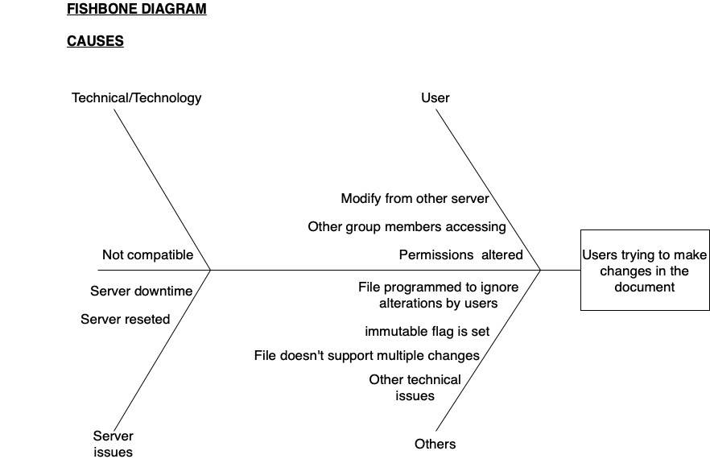

**EXPLANATION OF POSSIBLE CAUSES IN THE FISHBONE DIAGRAM**

**PROBLEM**

Users can’t be able to modify the document on the linux server that they have been working for the past few weeks.

**USERS**

**1. Permissions altered**

It is possible that someone has altered the permissions for modifying the file (document).

**2. Accessing from other group members**

It is feasible that the users are trying to modify the file from other group members communities which does not allow them permission to change the file.

**3. Modifying from a different server**

It is a possibility that the users are trying to alter the file from a different server or a remote server which in turn does not allow the users to alter the file.

**TECHNICAL/TECHNOLOGICAL ISSUE**

1. **Not compatible**

The issue can be due to the technological bounds among the users. Maybe the technology that the users are currently using is not compatible with the file created by them in the Linux server.

**SERVER**

1. **SERVER DOWNTIME**

Another main cause for the file not supporting further modifications made to it can be because of server outages or server downtimes. At times, the server undergoes outages and due to that reason the file has been reset to not allow any further modifications to it.

**2. SERVER RESET**

If due to some reason the Linux server has been reset then automatically the file will be set to prohibit any further modifications made to it by the user.

**OTHERS**

1. **File programmed in a way that it does not allow modifications**

There is a chance that the document created by the users has been programmed by someone in such a way that it does not allow any further modifications to it.

**2. Immutable flag has been set**

If there is an immutable flag set for the document, then the file will not accept any further modifications to it.

**3. File does not support multiple changes**

There is also a possibility with the file that it only accepts several alterations made to it. If the number of modifications exceeds the limit then it will not allow to edit the document further on.

**4. Other technical issues**

Moreover, there is a slim chance that the problem due to which the file in the Linux server does not allow modifications to it, is completely new for us. Hence, in that case it is a good advice to contact an expert system administrator to solve this issue.

**MIND MAP**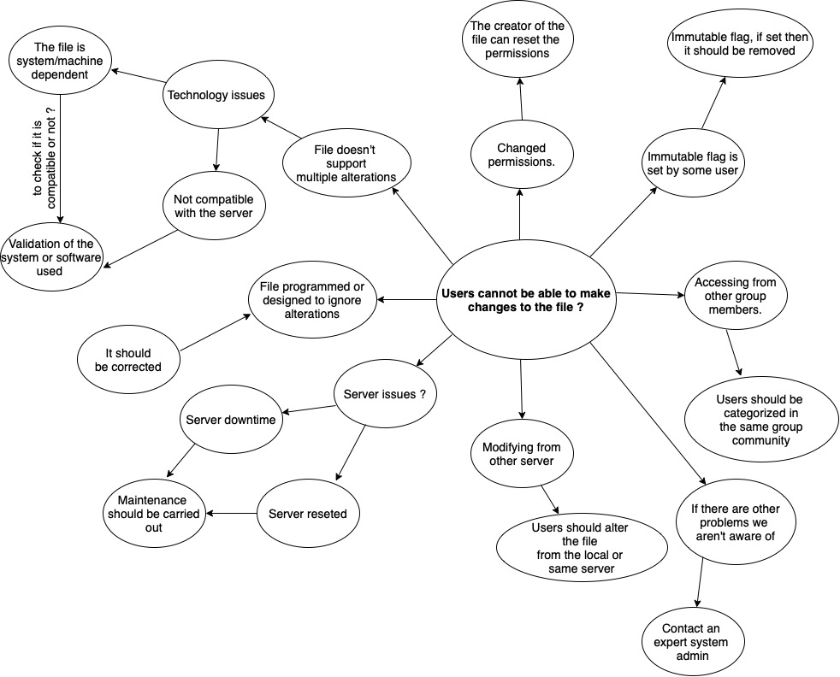

**SOLUTIONS**

1. **TO CHANGE THE PERMISSIONS FOR THE FILE**

The most logical solution to solve this issue is by simply, changing the permissions which ultimately allow users to make alteration in the document. This is the most simplest and reliable solution among the other solutions. One can easily change the permissions by using the chmod command with symbolic or else octet method.

**2. REGULAR MAINTENANCE SHOULD BE CARRIED OUT**

Regular maintenance of the server is the most important thing to do as a system administrator. There are several technical problems/ issues that might attack the server so in order to avoid those problems regular server maintenance should be carried out. By doing, there are some chances that might help to tackle this problem.

**3. AVOID USING REMOTE SERVERS TO ACCESS THE FILE**

There are certain times when we are expected to work remotely, especially during a pandemic. However, in order to access our local server we are at times forced to access it through a remote server but at times the permissions have been set for the file in that way which will not allow any access or changes made from a different or a remote server. So, it is advisable to avoid making alterations from a remote server

**4. CHECK AND REMOVE THE IMMUTABLE FLAG**

Immutable flags are placed on the Linux files or directories to restrict any file modifications made to it. So, it is always advisable to check if the file has any immutable flag placed on it or not.

**5. CONSULT AN EXPERT SYSTEM ADMINISTRATOR**

It is possible that the problem is much more different than we thought of and it is our first time dealing with it. Hence, in that case, it is always better to take advice or guidance from an expert system administrator.

**TRADE OFF ANALYSIS FOR IMMEDIATE OPTIONS**

1. **TO CHANGE THE PERMISSIONS FOR THE FILE**

very fast, simpler and the most reliable solution for the given problem.

**2. REGULAR MAINTENANCE SHOULD BE CARRIED OUT**

It is a tedious and slow process to carry out maintenance of the server and also not much reliable as compared to changing permissions for the file.

**3. AVOID USING REMOTE SERVERS TO ACCESS THE FILE**

It is the least reliable solution among the ones which are mentioned. Since, it will be the least preferred for a system administrator to access the local server from a remote server unless there has been a pandemic or a situation where the users cannot be able to present physically.

**4. CHECK AND REMOVE THE IMMUTABLE FLAG**

It is the fastest way to deal with this problem since we only have to check if an immutable flag has been placed on the file or not. If yes, the we ought to remove the flag from the file in order to allow further modifications.

**5. CONSULT AN EXPERT SYSTEM ADMINISTRATOR**

It is very fast process and also reliable. Contacting the system administration has the most chances to solve the given issue.

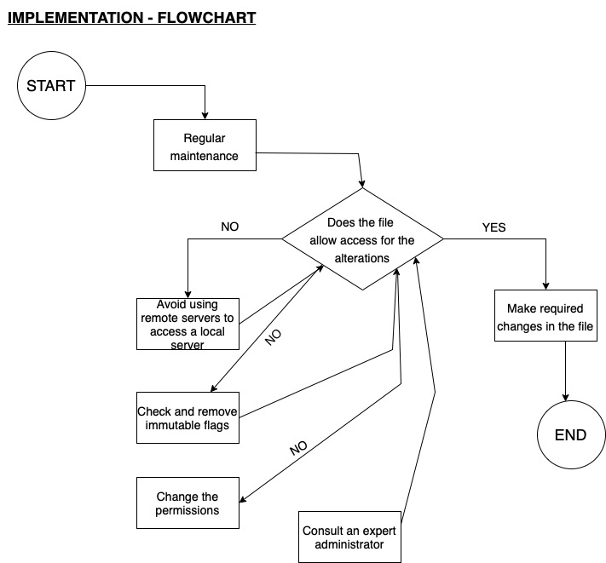

**FLOWCHART EXPLANATION**

The instructions which are mentioned below are based on three main causes for the problem which are :-

1. Server
2. Technology/ Technical issue
3. Users

* There are a few ways by following which the group member can possibly be able to avoid this problem.

- Firstly, to avoid this problem we have to perform regular maintenance of the server so if the problem of not being able to modify the file has been resolved then the users will be able to modify the file/ document. From carrying out the maintenance, the majority of the server issues will be solved.

-Secondly, if the above way does not able to help in order to tackle the problem then we have to implement our second resort which is to avoid using a remote server for accessing a file on a local server. Since, there are certain permissions set for the file which does not allow a user to modify a file from a remote server. If it solves the problem, then the users will be able to modify the file. If not, then they may proceed to the next step.

-Thirdly, if the previous steps/ ways did not work for the given problem then the users can check if the file has an immutable flag placed to it or not. If there is an immutable flag placed on the file then the user has to remove it since it does not allow to make any further changes to the file/ document.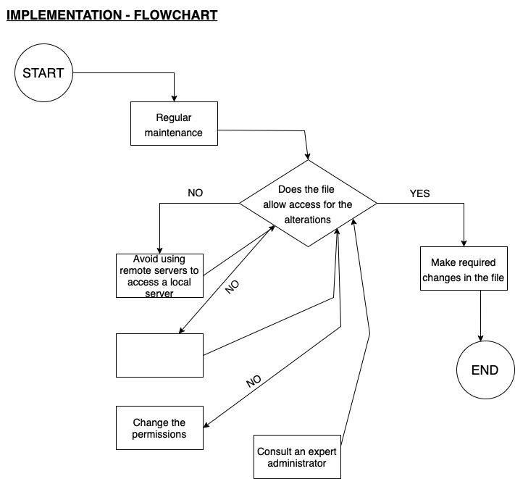



**-**If there is no immutable flag placed on the file/ document then the owner of the file/ document i.e, the Users can just change the permissions of the file to allow access for modifying the file. Hence, just by changing the file permissions, it will easily allow the users to modify the file.

-If all the mentioned ways does not work, then the last resort is to contact an expert system administrator for some guidance or advice in order to fix the issue since, there might be any other problem that we have not thought of yet.

**PRESENTATION SCRIPT :**

1. DEV’S SCRIPT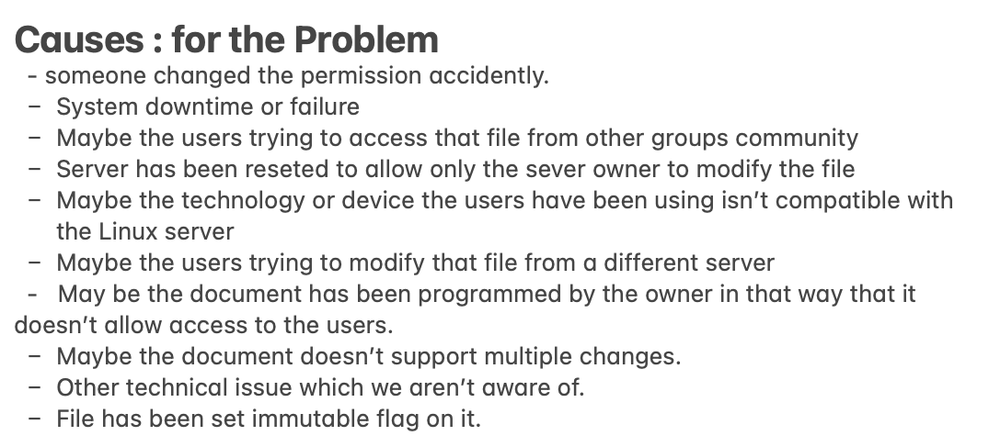

2. SERGE’S SCRIPT